**Assignment**

**Math Optimization II**

**ISM-6436 Operations & Supply Chain Processes**

1. The Sentry Lock Corporation manufactures a popular commercial security lock at plants in Macon, Louisville, Detroit, and Phoenix. The per-unit cost of production at each plant is $35.50, $37.50, $39.00, and $36.25 respectively while annual production capacity at each plant is 18,000, 15,000, 25,000, and 20,000. Sentry’s locks are sold to retailers through wholesale distributor in seven cities across the US. Prices per unit are negotiated individually with the distributors and are given below. Additionally, the unit cost of shipping from each plant to each distributor is summarized below along with the maximum demand for each distributor. Total amounts shipped to distributors cannot exceed these amounts.

|  |  |  |  |  |  |  |  |
| --- | --- | --- | --- | --- | --- | --- | --- |
| Distributors | Tacoma | San Diego | Dallas | Denver | St. Louis | Tampa | Baltimore |
| Plants |
| Macon | 2.50 | 2.75 | 1.75 | 2.00 | 2.10 | 1.80 | 1.65 |
| Louisville | 1.85 | 1.90 | 1.50 | 1.60 | 1.00 | 1.90 | 1.85 |
| Detroit | 2.30 | 2.25 | 1.85 | 1.25 | 1.50 | 2.25 | 2.00 |
| Phoenix | 1.90 | .90 | 1.60 | 1.75 | 2.00 | 2.50 | 2.65 |
| Maximum  Demand | 8,500 | 14,500 | 13,500 | 12,600 | 18,000 | 15,000 | 9,000 |
| Price to  Distributor | $56 | $58 | $62 | $65 | $49 | $42 | $52 |

Sentry wants to determine how to sell and ship locks from plants to distributors such that profit to Sentry is maximized. Formulate and solve the appropriate spreadsheet model to determine this shipment pattern.

1. Fresh Fruits imports bananas each month from Honduras and Costa Rica. Fresh Fruits buys its bananas on the market in these countries each month from local producers. This month the price of bananas is $820 per ton in Honduras and $860 per ton in Costa Rica.

Fresh Fruits can bring bananas into the US via warehouses it can lease in Miami, Houston, San Diego, and Wilmington, DE. Monthly lease costs for import facilities in these cities is $250,000, and capacity for handling bananas at these facilities is no problem. Shipments are then made from these import facilities to grocery retailers in those four cities as well as grocers in Denver, Kansas City, Fort Worth, Chicago, and Portland, OR. This month 200 tons of bananas are expected to be available for purchase from trusted vendors in Honduras and 150 tons from similar vendors in Costa Rica. The cost to transport bananas from Central America to the United States is estimated to be $2 per ton-mile, while the cost to move bananas from the import facilities to retail grocers will be $4 per ton-mile.

Formulate and solve a network model to 1) determine how many pounds of bananas should be purchased from Honduras and Costa Rica this month, 2) which potential import facilities should be leased, 3) how many pounds of bananas should be shipped into each of these facilities, and 4) how bananas should be distributed from these facilities to retail grocers. The goal of your model should be to design a supply chain system to minimize this month’s total cost of buying and transporting bananas for Fresh Fruits.

|  |  |  |  |  |
| --- | --- | --- | --- | --- |
| **Mileage Distance** | | | | |
|  | Miami | San Diego | Houston | Wilmington, DE |
| Honduras | 930 | 2300 | 1200 | 1800 |
| Costa Rica | 1150 | 2600 | 1550 | 2100 |

|  |  |  |  |  |  |  |  |  |  |
| --- | --- | --- | --- | --- | --- | --- | --- | --- | --- |
| **Mileage Distance** | | | | | | | | | |
|  | Denver | Kansas City | Ft. Worth | Chicago | Portland, OR | Miami | San Diego | Houston | Wilmington, DE |
| Miami | 2100 | 1500 | 1350 | 1400 | 3300 | 0 | 2700 | 1200 | 1200 |
| San Diego | 1100 | 1700 | 1300 | 2100 | 1100 | 2700 | 0 | 1500 | 2700 |
| Houston | 1050 | 750 | 300 | 1100 | 2300 | 1200 | 1500 | 0 | 1500 |
| Wilmington, DE | 1700 | 1100 | 1500 | 750 | 2900 | 1200 | 2700 | 1500 | 0 |

|  |  |  |  |  |  |  |  |  |
| --- | --- | --- | --- | --- | --- | --- | --- | --- |
| **Banana Demand This Month (Pounds)** | | | | | | | | |
| Denver | Kansas City | Ft. Worth | Chicago | Portland, OR | Miami | San Diego | Houston | Wilmington, DE |
| 60000 | 40000 | 65000 | 70000 | 28000 | 58000 | 62000 | 75000 | 30000 |

1. An IT department wishes to assign five programmers to five programming tasks (one programmer to each task). Management has estimated the total number of days each programmer would take if assigned to each job and these estimates are summarized below. Determine the assignment of programmers to tasks which would minimize the total programmer days required to complete all five jobs.

|  |  |  |  |  |  |  |
| --- | --- | --- | --- | --- | --- | --- |
|  |  | **Tasks** | | | | |
|  |  | 1 | 2 | 3 | 4 | 5 |
| **Programmers** | 1 | 50 | 25 | 78 | 64 | 60 |
| 2 | 43 | 30 | 70 | 56 | 72 |
| 3 | 60 | 28 | 80 | 66 | 68 |
| 4 | 54 | 29 | 75 | 60 | 70 |
| 5 | 45 | 32 | 70 | 62 | 75 |

1. 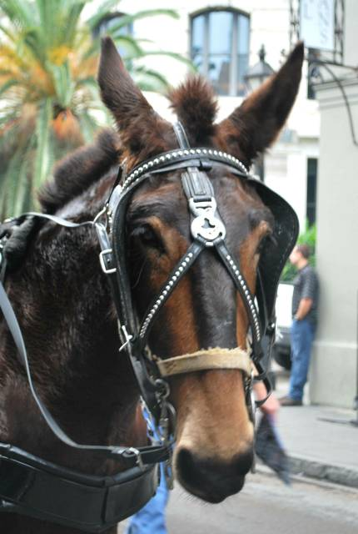Cletus the Mule pulls one of the many open carriages offering rides to tourists in New Orleans’ famous French Quarter. Several times each day Cletus follows a pre-determined route through the streets of the Quarter, passing by famous restaurants, shops, and historic landmarks. At each place Cletus’ driver tells passengers stories about these locations and New Orleans’ colorful past.

Mule-drawn carriage rides are common in the French Quarter and are heavily regulated, both to protect the animals’ welfare and to control carriage traffic on the Quarter’s narrow 18th Century streets. Regulations state Cletus’ tour route must begin and end at the Decatur Street Carriage Stand in front of Jackson Square. Additionally, regulation closes some streets to Cletus to reduce the impact of slow moving carriages on the Quarter’s already-challenging traffic. Cletus’ tour route may not leave the French Quarter.

While Cletus’ owners generate income by selling tour tickets to passengers, revenue also comes from subscription fees businesses pay to be on Cletus’ route. Businesses such as notable restaurants and shops must pay the subscription fee to be a part of the tour and be promoted to tourists by the driver. General interest and historic locations such as the Ursuline Convent do not pay a fee to be part of Cletus’ tour since they add “local color” to the route.

The next page of this assignment shows a map of the French Quarter with 14 tour stops planned for Cletus. On each round through the Quarter Cletus must travel to each of these locations. The Decatur Street Carriage Stand, the mandated start/end of the tour, is marked #1 on the map. The following page has a distance matrix for the 14 locations with distances given in meters. Note the matrix isn’t symmetric. That is, the distance from Lafitte’s Blacksmith Shop to the New Orleans Pharmacy Museum is greater than from the Pharmacy Museum to Lafitte’s. This is because the Quarter’s pattern of alternating one-way streets can complicate route planning.

Assuming Cletus starts and ends his tour at the Decatur Street Carriage Stand, use a Traveling Salesman methodology to determine a short route which will include all 14 designated locations in the French Quarter. Show the order of stops on the route and the total distance Cletus would travel for one tour of the Quarter.

*Note: In this problem there are over 87 billion possible routes for Cletus. It could theoretically take Excel Solver several months to enumerate all solutions and prove the absolute shortest route for Cletus. However, Excel Solver should converge to a good – though not a proven optimal -- solution within a few minutes. You are only being asked to find this “good” solution.*

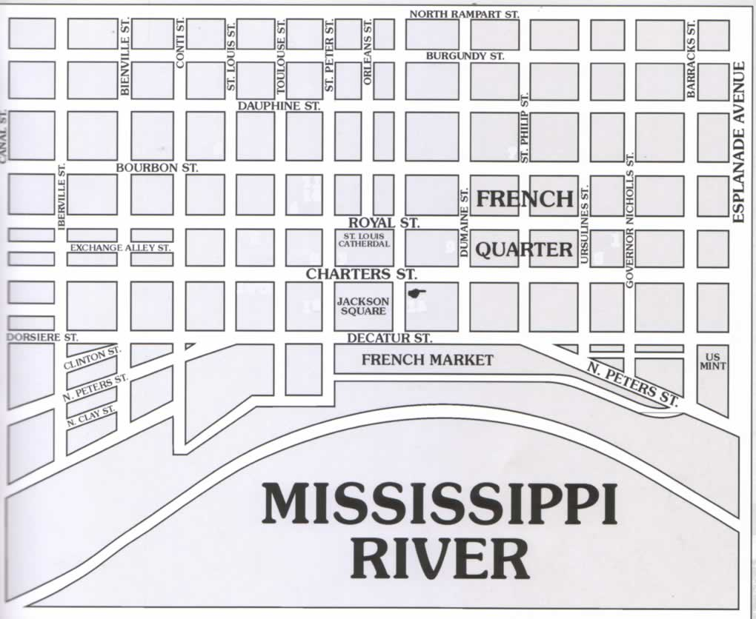

12

13

14

3

10

4

8

2

5

6

9

7

11

1

|  |  |  |  |
| --- | --- | --- | --- |
| 1 | Jackson Square/Carriage Stand | 8 | New Orleans Pharmacy Museum |
| 2 | The Cabildo | 9 | Galier House |
| 3 | The Old Absinth House | 10 | The Cornstalk |
| 4 | Pat O’Briens | 11 | The French Market |
| 5 | Marie Laveau’s House of Voodoo | 12 | Café du Monde |
| 6 | Lafitte’s Blacksmith Shop | 13 | Broussard’s Restaurant |
| 7 | Ursuline Convent | 14 | Brennan’s Restaurant |

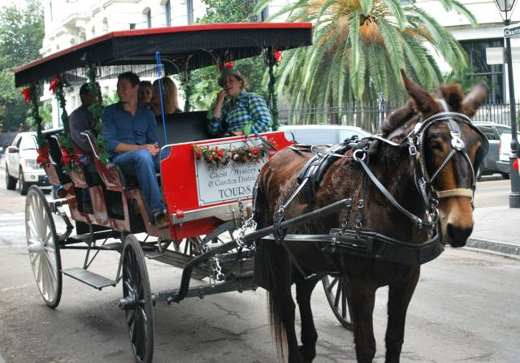



***Note: The above table is an embedded Microsoft Excel worksheet. Double click this table to activate the worksheet.***

**Instructions:** Your deliverable will be a functioning Excel spreadsheet with each problem on a separate worksheet page. For each problem a fully populated Solver dialog box will be available and your model should solve in a test by the instructor. The deliverable will be uploaded to Canvas by the assignment deadline stated on the Lesson Plan. Include a cover page for your file which lists your name and the names of any other group members deserving credit for this work. Group sizes may be no larger than 4, and only one group member need submit the final deliverable.